Week 5 - Monday Questions

1. How many actors are there with the last name ‘Wahlberg’?
   1. 2
   2. select first_name, last_name  
      from actor  
      where last_name = 'Wahlberg';
2. How many payments were made between $3.99 and $5.99?
   1. 5602
   2. SELECT amount

FROM payment

WHERE amount between 3.99 and 5.99;

1. What film does the store have the most of? (search in inventory)
   1. 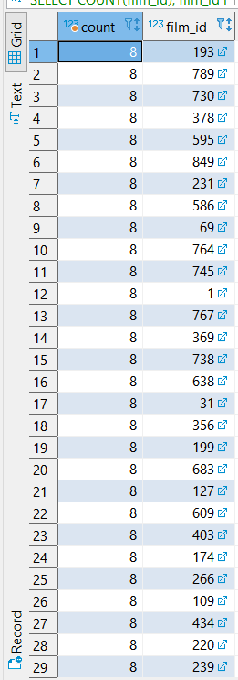

SELECT COUNT(film_id), film_id

FROM inventory

GROUP BY film_id

order by count desc;

1. How many customers have the last name ‘William’?
   1. 0
   2. SELECT COUNT(last_name), last_name  
      FROM customer

where last_name = 'William'

GROUP BY last_name

1. What store employee (get the id) sold the most rentals?
   1. Staff_id = 1; rental_id count = 8040
   2. select staff_id, count(rental_id)

from rental

group by staff_id

1. How many different district names are there?
   1. 378
   2. select count(distinct district), district

from address

group by district

1. What film has the most actors in it? (use film_actor table and get film_id)
   1. Film_id = 508; count actor_id = 15
   2. SELECT film_id , count( actor_id)

from film_actor

GROUP BY film_id

order by count desc ;

1. From store_id 1how many customers have a last name ending with ‘es’? (use customer table)
   1. 13
   2. select last_name, store_id

from customer

where last_name like '%es' and store_id = 1;

1. How many payment amounts (4.99, 5.99, etc.) had a number of rentals above 250 for customers with ids between 380 and 430? (use group by and having > 250)
   1. 3
   2. select count(amount), amount from payment

where customer_id between 380 and 430

group by amount

having count(amount) > 250;

1. Within the film table, how many rating categories are there? And what rating has the most movies total?
   1. Count ratings = 5; rating most = PG-13
   2. select count(rating), rating from film

group by rating

order by count